1.setTimeout()

The setTimeout Javascript method is used to call a function after a certain period of time.

2.setInterval()

The setInterval Javascript method is used to call a function repeatedly at a specified interval of time.

<html>

<body>

<h1>The Window Object</h1>

<h2>The setTimeout() Methods</h2>

<h2 id="demo"></h2>

<script>

const myTimeout = setTimeout(myGreeting, 5000)//5 seconds;

function myGreeting() {

  document.getElementById("demo").innerHTML = "Welcome to India"

}

</script>

</body>

</html>

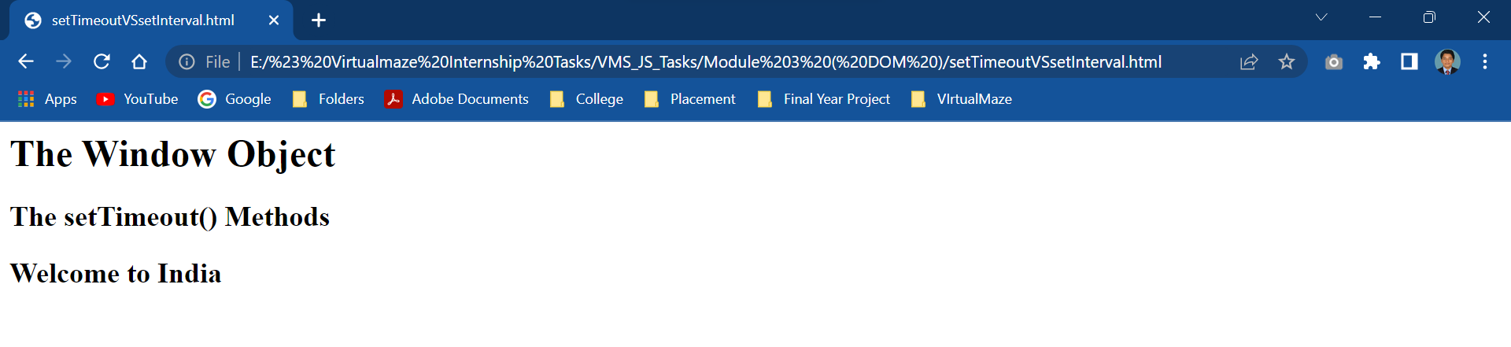

<html>

<body>

<h2>The setInterval() Method</h2>

<p id="demo"></p>

<script>

const element = document.getElementById("demo");

setInterval(function() {element.innerHTML += "Hello "}, 1000);

</script>

</body>

</html>

